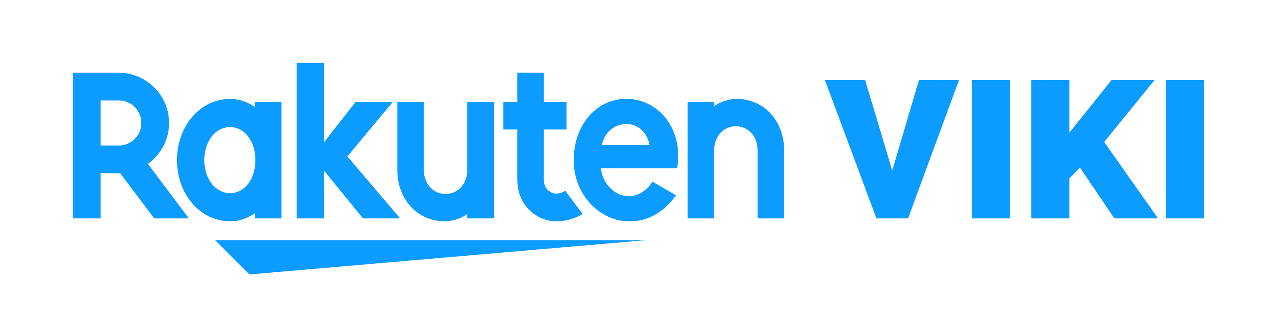

Content Partnership Coordinator

Viki, a Rakuten Company (Japan Stock Exchange: 4755), is a global TV site with tens of millions of viewers a month watching primetime TV and movies from around the world, subtitled in over 200 languages by a community of fans. With billions of videos viewed and more than one billion words translated, Viki brings global entertainment to fans everywhere.

We are looking for a Content Partnership Coordinator to join our Team at Korea office located in Sinsa, Seoul to work with growing our existing relationships from Korea. This a full-time position possible after 3-month probation period.

Responsibilities:
- Assist revenue reports for Content team
- Conduct content research and performance analysis
- Conduct data analysis, market research and business report related to the content
- Translating content related materials
- Work with global teams for Korean content launch and campaigns

Qualifications
- Completed a bachelor’s/master’s degree
- Proficiency in English and Korean
- Data Analytics skills are highly desirable
- Up to 3 years experience in media or involvement preferred
- Desire to learn more about online video
- Highly proficient with MS Office, especially PowerPoint and Excel
- Strong organizational skills with the ability to multi-task

Start Date: ASAP

