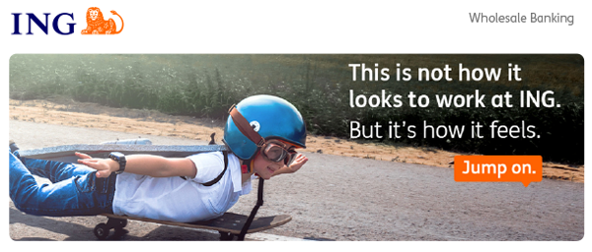
ING WB Asia Internship Programme 2025
“At ING, we’re redefining what it means to be a bank and we’re looking for people with the right skills to jump on. If you’re a smart, driven student with global ambitions who wants to make a real difference, our internship might be for you.”

Position: | Intern (Undergraduate)
Dept/Function: | Debt Capital Markets (“DCM”)
Internship Period: | Full time for 6 Months (Starting from Jul 2025)
Openings | 1 intern
Please note that the application deadline for this internship is 23 May 2025.

Why ING?
The world of banking is changing faster than ever. That’s why we at ING are always broadening our horizons. Our people have a forward-thinking mentality, a strong can-do spirit and enjoy working in an agile environment.

ING in Asia Pacific
In Asia Pacific, ING offers wholesale banking across 11 markets, namely Australia, China, Hong Kong SAR, India, Indonesia, Japan, the Philippines, Singapore, South Korea, Taiwan and Vietnam. ING offers both retail and wholesale banking services in Australia. The bank also started its digital banking platform in the Philippines in 2018. ING's regional presence includes a 13% stake in Bank of Beijing, China and a 23% stake in TMBThanachart Bank, Thailand.

What does the DCM Team do in ING?
The responsibilities of a DCM intern in ING Seoul Securities Branch include supporting the origination and execution process of Debt Capital Markets products and carrying out effective communication with other relevant desks and stakeholders in the process. In addition, DCM intern is responsible for daily monitoring of financial markets and quantitative analysis of relevant market data, as well as creating marketing materials for pitches

What would you be doing?
- Supporting DCM origination activities
- Creation/delivery of marketing materials and proposals
- Assisting execution of public bond offerings
- Assisting execution of MTN private placements
- Interaction with other units within ING, e.g.) fixed income syndicate, MTN syndicate, as well as risk and industry bankers
- Participation in DCMCC, RGLC, and UW committee calls and memo write ups
Assistance for ad-hoc-based client requests

What qualities and skills are we looking for?
We are looking for a passionate individual who meets the following criteria:
- Enrolled in a full time Bachelor's program (Business major preferred)
- Being responsive in timely manner
- Fluent in English and Korean, both verbally and written
- Strong communication and interpersonal skills and a good team player
- High level of self-motivation and result-oriented approach
- Proficiency in Microsoft Office (especially Powerpoint and Excel)

What would you gain from this internship?
- Understanding on DCM business and necessary skill set
- Live experiences of public bond deal execution & MTN private placements
- Communication with other units & business lines
- Learning internal approval process

Candidates who are interested in this job position should apply directly through ING Career Website: https://ing.wd3.myworkdayjobs.com/ICSGBLCOR/job/Seoul/XMLNAME--Securities--Debt-Capital-Markets---2025-2H-Intern_REQ-10095791-1

Need more information?
For information on ING Wholesale Bank, visit https://www.ingwb.com/

